Title: Today I feel

Exercise Code: SLINTEGRA046

|  |  |  |
| --- | --- | --- |
| Modules: | Group size: | Duration: |
| 1. Social Learning  5. Conflict Solving Strategies  6. Problem Solving Strategies | Individual  Small group  Large group | 20 min |

**Purpose:**

* To learn how to deal with your feelings in a positive way
* To use emotions constructively in making decisions and in the process of accepting various work tasks and demands
* To learn how to recognize and assess one’s own feelings when interacting with others

**Description:** Participants use the picture below to identify how they feel today. 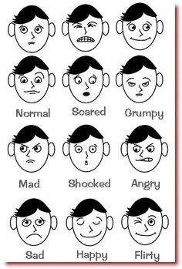(<https://www.pinterest.com/callahanjennife/feelings-and-emotions/>)

Subsequently follows a discussion in the group that will touch upon the theme of emotions and what role they play in the group or in a work environment. Recognizing the feelings and making a conscious decision to react positively to their feelings is the difference between a good day and a bad day.

**Methods:**

The pictures are mostly to help those that describe their emotional states easier with the use of a certain object picture or figure. Let the picture be the cue for the description of your emotional state.

**Source/Literature:**

Modified and adapted from Teaching Center, Washington University, St. Louis

**Handouts:**

Today I feel